Links for reference

As of now html 5.2 is latest even on 2024

|  |  |
| --- | --- |
| Static website is a website which is same for every user, | Dynamic website is a website which changes for every user  Ex:- Udemy is a dynamic website- which looks differently for every user  For each user, courses recommendation is different based on his enrolments so Udemy is dynamic |

HTML – hyper(links to other page using <a href> tags) text markup (u can bold or italize some elements means highlight) language

<https://developer.mozilla.org/en-US/docs/Web/HTML>

<https://html.spec.whatwg.org/multipage/>

Any website u hit , we will get the html, css, JavaScript files

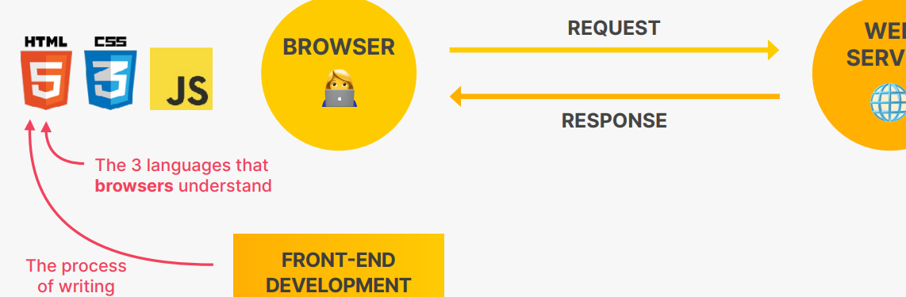

|  |  |
| --- | --- |
| HTML | It is the actual data of the page – text, images, button |
| CSS | For styling |
| Js (this is the actual programming language of front end) | Add dynamic and interactive effects,  To load data from web server  To manipulate the content |

# basics codes

## With head, title

1. The <!DOCTYPE html> declaration defines that this document is an HTML5 document represents the document type, and helps browsers to display web pages correctly.

It must only appear once, at the top of the page (before any HTML tags).

1. The <html> element is the root element of an HTML page
2. The <head> --**METADATA**  element contains meta information about the HTML page
3. The <title> element specifies a title for the HTML page (which is shown in the browser's title bar or in the page's tab)
4. The <body> **DATA** -element defines the document's body, and is a container for all the visible contents, such as headings, paragraphs, images, hyperlinks, tables, lists, etc.

#### HTML element vs HTML tag

<h1> // here h1 is a tag, every tag will internally have some attributes like <input type =”text”> here input is tag, type is attribute of that tag

<h1> I am a paragraph </h1> this total tag+content == element

<input type=”checkbox”> // Here input is the tag and “type” is the attribute, “checkbox” is the attributes value

Most of the tags will have some attributes

<input type=”text” id=”one”> make sure id attribute value must be unique in the entire page

Note: for every tag we can have an attribute called title

<p title=”t1”>

<input type=”text” title=”ad”>

<!DOCTYPE html>  
<html>  
<head>  
<title>Page Title</title>  
</head>  
<body>  
  
<h1>My First Heading</h1>  
<p>My first paragraph.</p>  
<a href="https://www.w3schools.com">This is a link</a>  
</body>  
</html>

## 2) HTML Attributes

<a href="https://www.w3schools.com">This is a link</a>

Here href is an attribute, attributes are used to provide additional info about HTML elements

The destination url must be specified in the href attribute,

<img src="w3schools.jpg" alt="W3Schools.com" width="104" height="142">

The source file (src), alternative text (alt), width, and height are provided as attributes:

## 3) all tags

<br> these is no closing tag for br, it is called empty element, because we cant keep content inside that element

|  |  |
| --- | --- |
| <Strong> |  |
| <div> | This div (divide) tag is used to segregate or group some elements |
| <h1> ….. <h6> | These are block elements , means these will take entire row |
| <a href= “www.google.com”>, , <p> |  |
| <b> // b means bold or to bring attention  <h4>vammov</h4>  <strong>vammov</strong> <br>  <b>vammov</b> | To bold  All these 3 tags gives same output |
| <p><em>vammov</em></p> // em means emphasize to make it italic or bend  <p><i>vammov</i></p> // italic or idiomatic | Both tags are to make italic, means slightly bend  Result  *vammov*  *vammov* |
| // super script and sub script – this is also block elements  <p>E=mc  <sup>2</sup></p>  <p>H <sub>2</sub> o</p>  This sub, sup elements are inline elements, just to bold and al | Result  E=mc 2  H 2 o |
| Ordered Vs. un-ordered lists  Ordered = will contain numbers  Un ordered will not contain number it just will have bullet points | |  |  | | --- | --- | | // Here li means list item  Ol – ordered list  Ul – un ordered list  <h2>Languages Lists</h2>  <ol>      <li>python</li>      <li>.Net</li>      <li>c++</li>      <li>Java          <ul>              <li>Core java </li>              <li>Spring</li>              <li>Hibernate</li>          </ul>      </li>  </ol>  <h2>Foods list</h2>  <ul>      <li>Millets</li>      <li>Bull driven oil</li>  </ul> | Result Languages Lists  1. python 2. .Net 3. c++ 4. Java    * Core java    * Spring    * Hibernate  Foods list  * Millets * Bull driven oil | |  |  | |
| Links  Anchor tags | This is also inline element  //This will append to current url  <li><a href="www.google.com">Goto google relative link</a></li>  //This will directly redirect to google as we added https  <li><a href="https://www.google.com">direct google link</a></li>      <a id="start1" href="https://www.google.com" target="_blank">Go to google</a>  Target=_blank means it will redirect to another website in next tab, not from current tab, so that current tab will remains same  //Below means inside our website it is redirecting to folder “pages” and file named “contact.html”  This is called relative redirect , means same page      <a href="pages/contact.html">Contact us here</a> |
| Anchor tags to navigate inside a html document  //we cant use class as, we must use id only  Below wont work  <a  href=".start">goto start</a> //This says navigate to class named start   <p class="start">        Lorem I </p>  A element with that class is there, but still it wont navigate | When web page is big, if u want to navigate from first to last then use as below  So always use id to navigate instead of class selector   <a href="#end">Go to end</a> // instead of giving direct google url, we are giving like goto that id tag    <p id="start"> Lorem ipsum </p>   <p id="end">   Lorem </p>  <a  href="#start">goto start</a> |
| Linking to same page elements | Assume if doc is so big if u want to redirect or goto same page elements  <h2 id="TreatDetails"> Acceptable Treats</h2> //These id must be unique   <a href="#TreatDetails"> Go to treat details </a> // Now if you see this anchor link goes to treat details link |
| Linking images | <img src="images/city.jpeg" alt="city skyline" />      <img src="images/cake.avif" alt="slice of birthday cake" />      <img        src="https://images.unsplash.com/photo-1667481020991-31186b791c13?ixlib=rb-4.0.3&ixid=MnwxMjA3fDB8MHxwaG90by1wYWdlfHx8fGVufDB8fHx8&auto=format&fit=crop&w=2070&q=80"        alt="desert landscape"      /> |
|  |  |

Basic tables

By default all the code inside table will be inside <tbody> and we have to mention explicitly about <thead>

|  |  |  |  |
| --- | --- | --- | --- |
| Basic table code |  | Row span and col span  Column span means spanning/extending that column across 2 columns | Standard HTML table |
| <table>      <tr>        <th>Movie Title </th>        <th>Release year</th>        <th>IMDB rating</th>      </tr>      <tr>        <td>Magadheera</td>        <td>2009</td>        <td>9/10</td>      </tr>    </table>  //result   |  |  |  | | --- | --- | --- | | **Movie Title** | **Release year** | **IMDB rating** | | Magadheera | 2009 | 9/10 |   // Here the problem is it won’t have borders and all | // its always best to include inside thead and tbody    <table>      <caption>Top movies in 2023</caption>      <thead>      <tr>        <th>Movie Title </th>        <th>Release year</th>        <th>IMDB rating</th>      </tr>    </thead>    <tbody>      <tr>        <td>Magadheera</td>        <td>2009</td>        <td>9/10</td>      </tr>    </tbody>    </table> | <table>      <caption>Top movies in 2023</caption>      <thead>      <tr>        <th>Movie Title </th>        <th>Release year</th>        <th>IMDB rating</th>      </tr>    </thead>    <tbody>      <tr>        <td>Magadheera</td>        <td>2009</td>        <td>9/10</td>      </tr>      <td colspan="2">Bahubali</td>      <td>10/10</td>    </tbody>    </table>    If u see this, the 2nd row is spanned or extended for 2 columns as there is no data | <table>  <caption>  It's Always Sunny Character Ages  </caption>  <thead>  <tr>  <th>Character</th>  <th>Age</th>  </tr>  </thead>  <tbody>  <tr>  <td>Frank</td>  <td>77</td>  </tr>  <tr>  <td>Deandra</td>  <td>46</td>  </tr>  <tr>  <td>Charlie</td>  <td>46</td>  </tr>  <tr>  <td>Mac</td>  <td>45</td>  </tr>  <tr>  <td>Dennis</td>  <td>47</td>  </tr>  </tbody>  <tfoot>  <tr>  <td>Average</td>  <td>52.2</td>  </tr>  </tfoot>  </table> |
|  |  |  |  |

## 4) HTML forms

Label your input properly by giving the name of those ids

Below is the Worst way of labelling

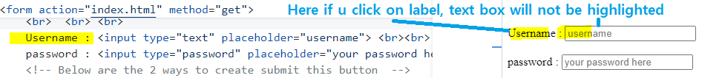

Best way

The main advantage is when u click on label, that corresponding box will be highlighted in yellow colour



 <label for="**u1**">Username : </label>// Here in for attribute u should give value as the id value for the target tag

        <input id="**u1**" type="text" placeholder="username"> <br><br>